# CAM-MIPI9281RAW-V2

# Compile Driver Source Code

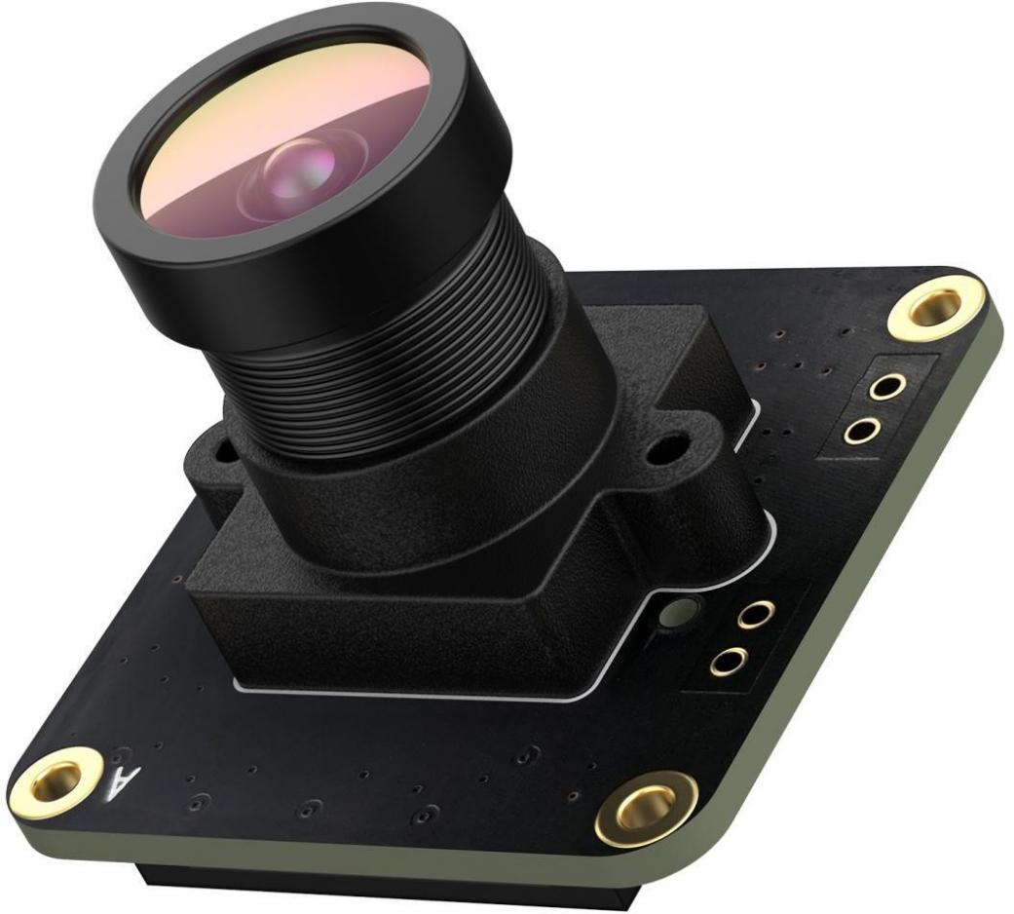

# Key Operations:

## Compile Driver Source Code

Step1 ,Download Source Code from our github:

|  |
| --- |
| $sudo git clone https://github.com/INNO-MAKER/CAM-OV9281RAW-V2.git |

Step2 ,Install the linux kernel header by:

|  |
| --- |
| $sudo apt-get install raspberrypi-kernel-headers |

Step3,Compile the driver source code

|  |
| --- |
| $cd CAM-OV9281RAW-V2/  $sudo chmod -R a+rwx *  $sudo tar -xzvf vc_mipi_ov9281_driver_pi_latice_linux5.10.63.tar.gz  $cd vc_mipi_ov9281_driver_pi_latice_linux5.10.63  $sudo ./clear.sh  $sudo make |

Step4,Install the innomaker driver

|  |
| --- |
| $sudo make install #Work on 8bit stream mode by default. |

## Enable Camera

Step1, edit /boot/config.txt

|  |
| --- |
| $sudo nano /boot/config.txt |

Add below content to the last line and reboot

|  |
| --- |
| dtoverlay=vc_mipi_ov9281 |

|  |
| --- |
| $sudo reboot |

**\*\*\* Remark If USE pi zero(bcm2835)**

|  |
| --- |
| dtoverlay=vc_mipi_ov9281,i2c_pins_28_29=1 |

**\*\*\* Remark If USE CM4 Dual Camera**

|  |
| --- |
| $sudo cp vc_mipi_ov9281_cm4_dual.dtbo /boot/overlays |

Add below content to the last line and reboot

|  |
| --- |
| dtoverlay=vc_mipi_ov9281_cm4_dual |